**Supplementary Material**

**Greigite formation in aqueous solutions: critical constraints into the role of iron and sulphur ratios, pH and Eh, and temperature using thermodynamic reaction process modelling.**

**Jack Turney**, Dominik Weiss, Adrian Muxworthy, Al Fraser

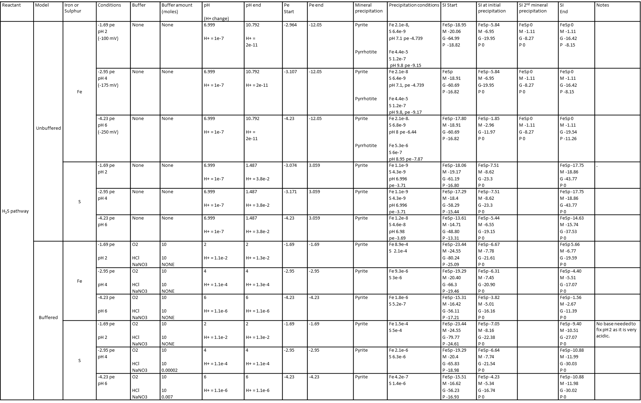

Table S1. Full experimental results for the H2S reaction pathway showing unbuffered and buffered solutions. Concentrations measured by molality (m).

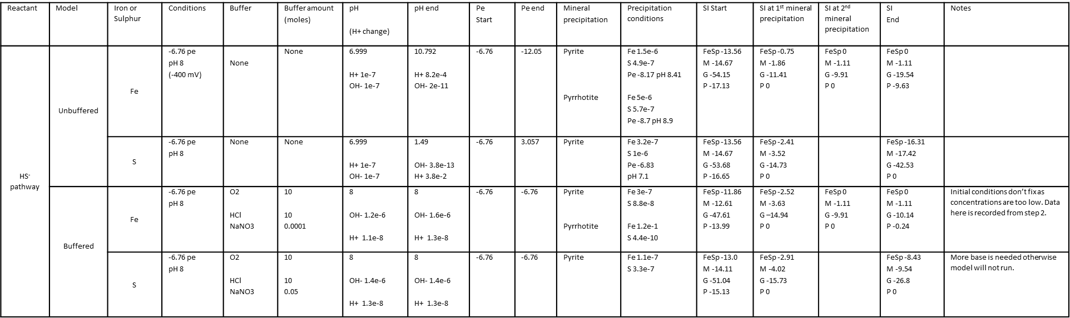

Table S2. Full experimental results for the HS- reaction pathway showing unbuffered and buffered solutions. Concentrations measured by molality (m).

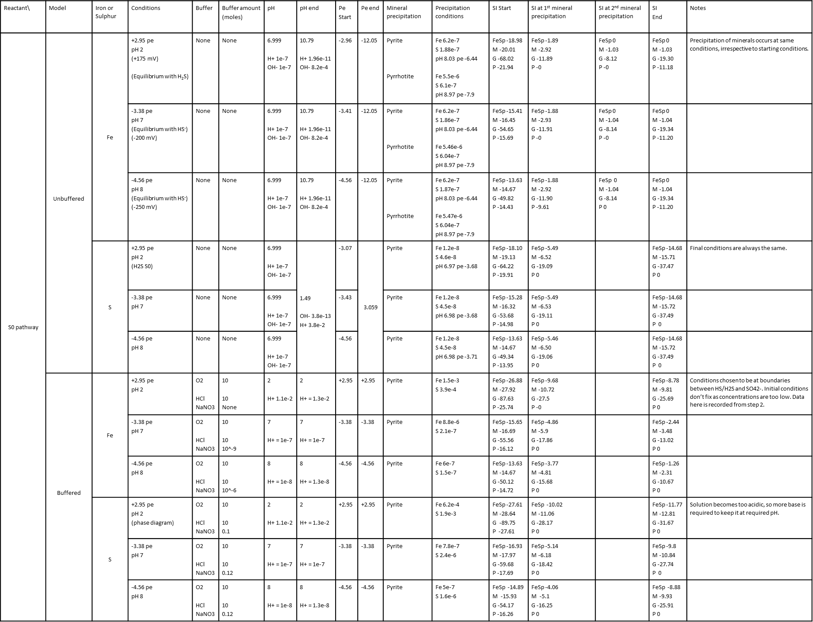

Table S3. Full experimental results for the S0 reaction pathway showing unbuffered and buffered solutions. Concentrations measured

by molality (m).

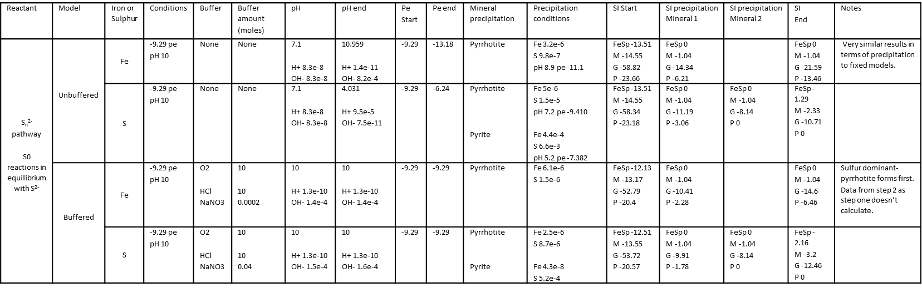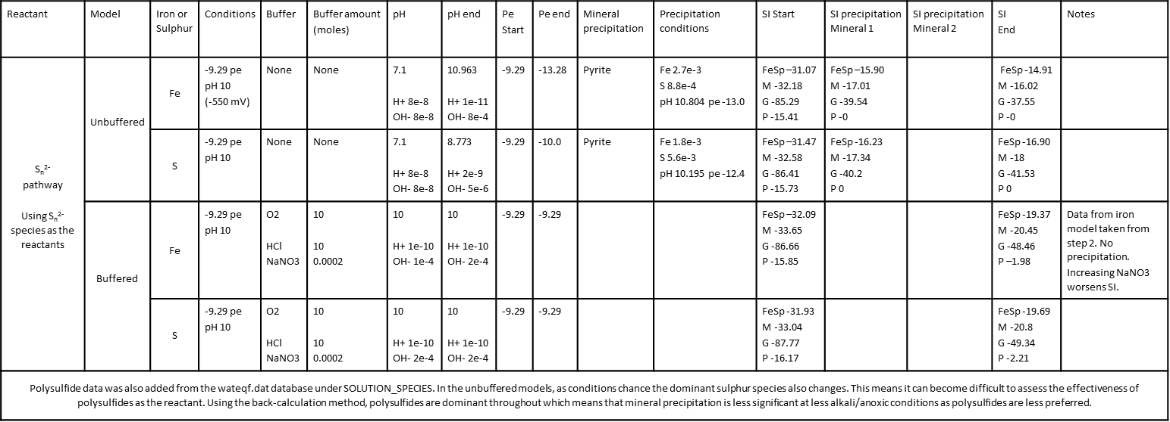

Table S5. Full experimental results for the polysulfide reaction pathway showing unbuffered and buffered solutions. Reactions use S0 which is in equilibrium with Sn2- and PHEREQC calculates the polysulfides species present under the specified conditions. Concentrations measured by molality (m).

Table S4. Full experimental results for the polysulfide reaction pathway showing unbuffered and buffered solutions. Reactions use individual polysulfide species. Concentrations measured by molality (m).

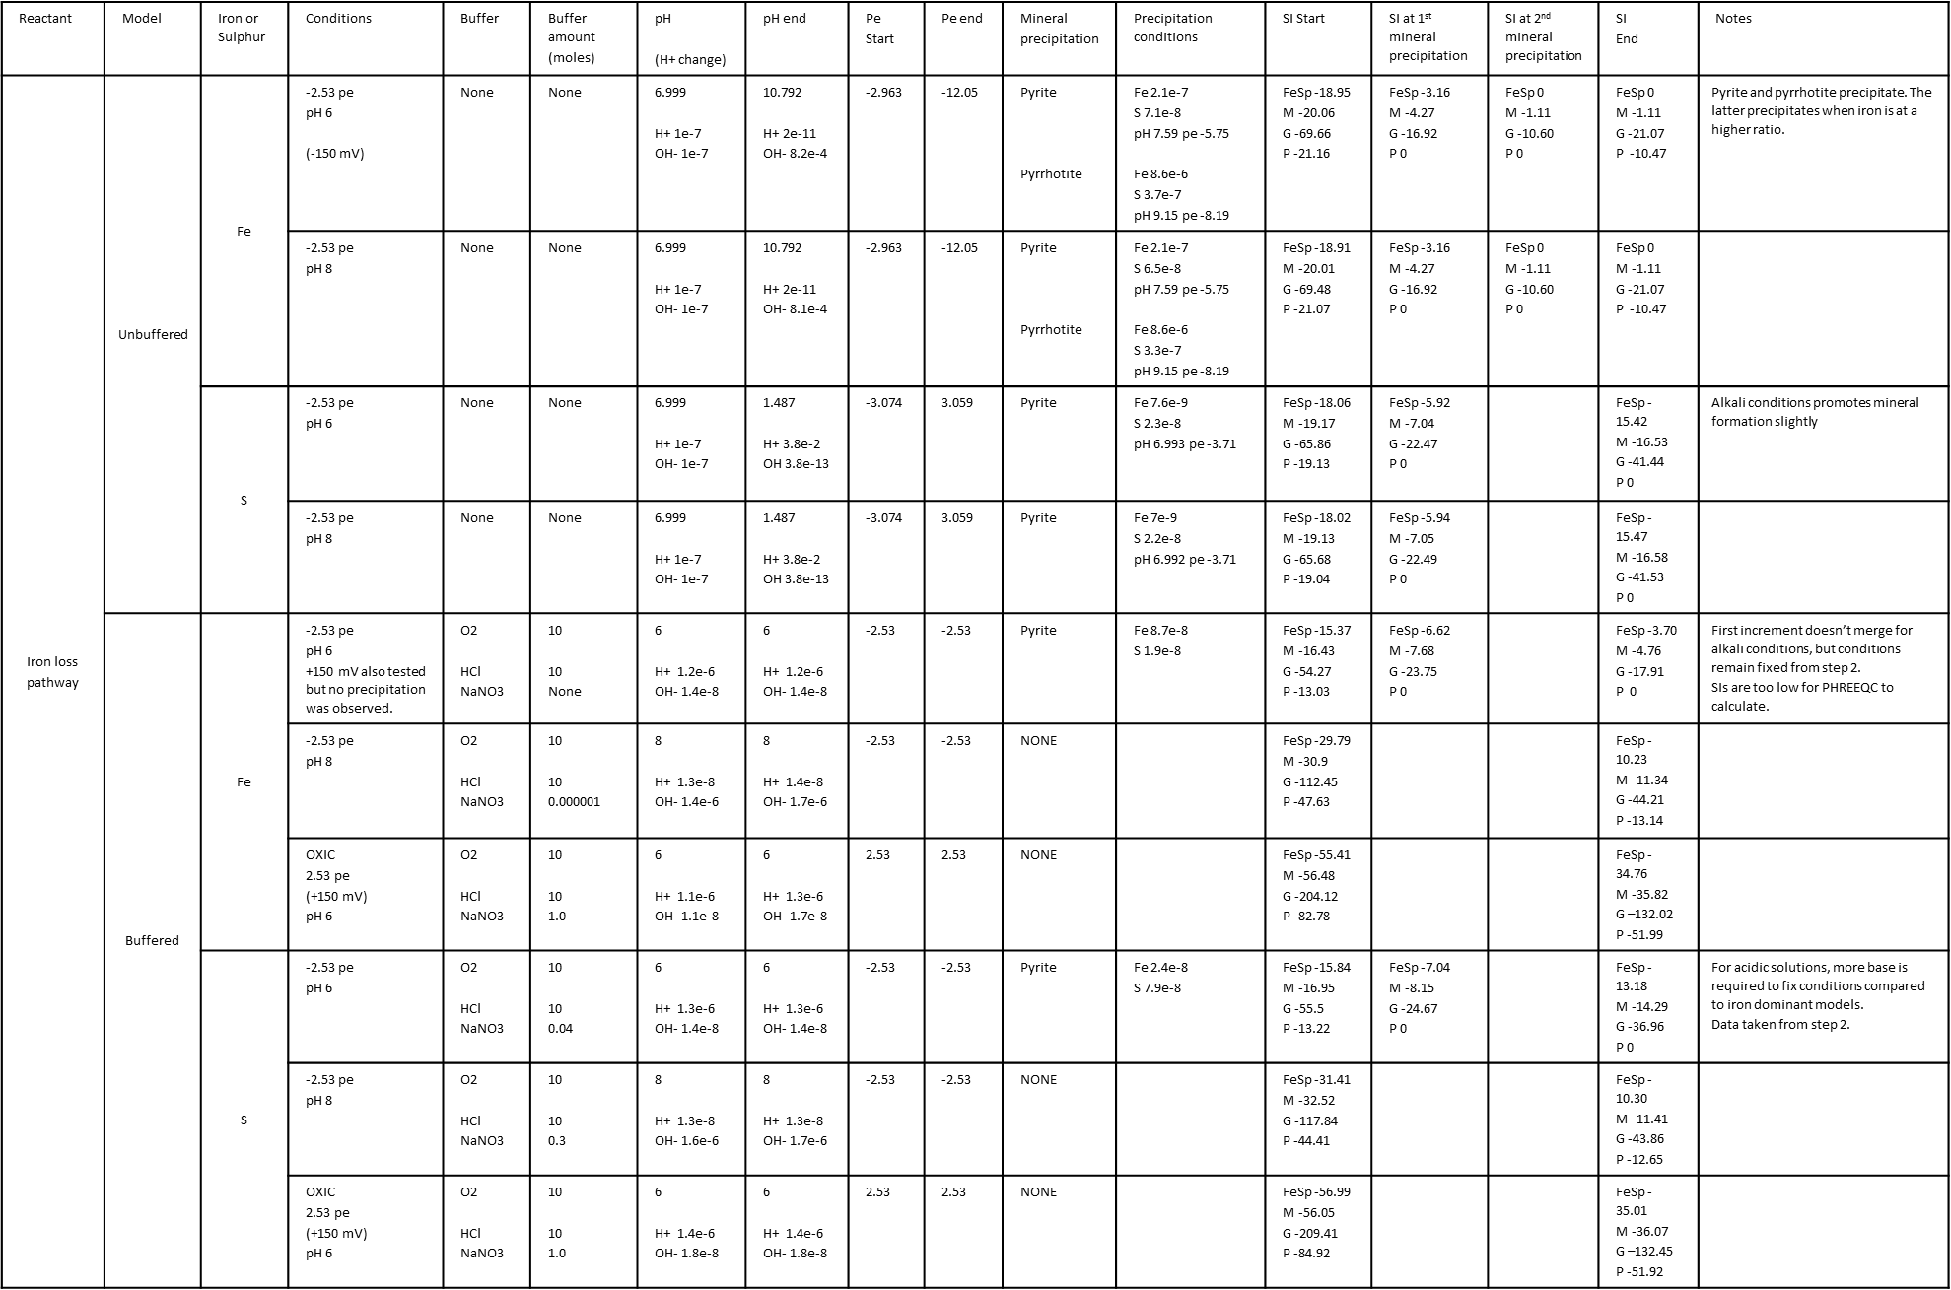

Table S6. Full experimental results for the iron loss reaction pathway showing unbuffered and buffered solutions. Concentrations measured by molality (m).

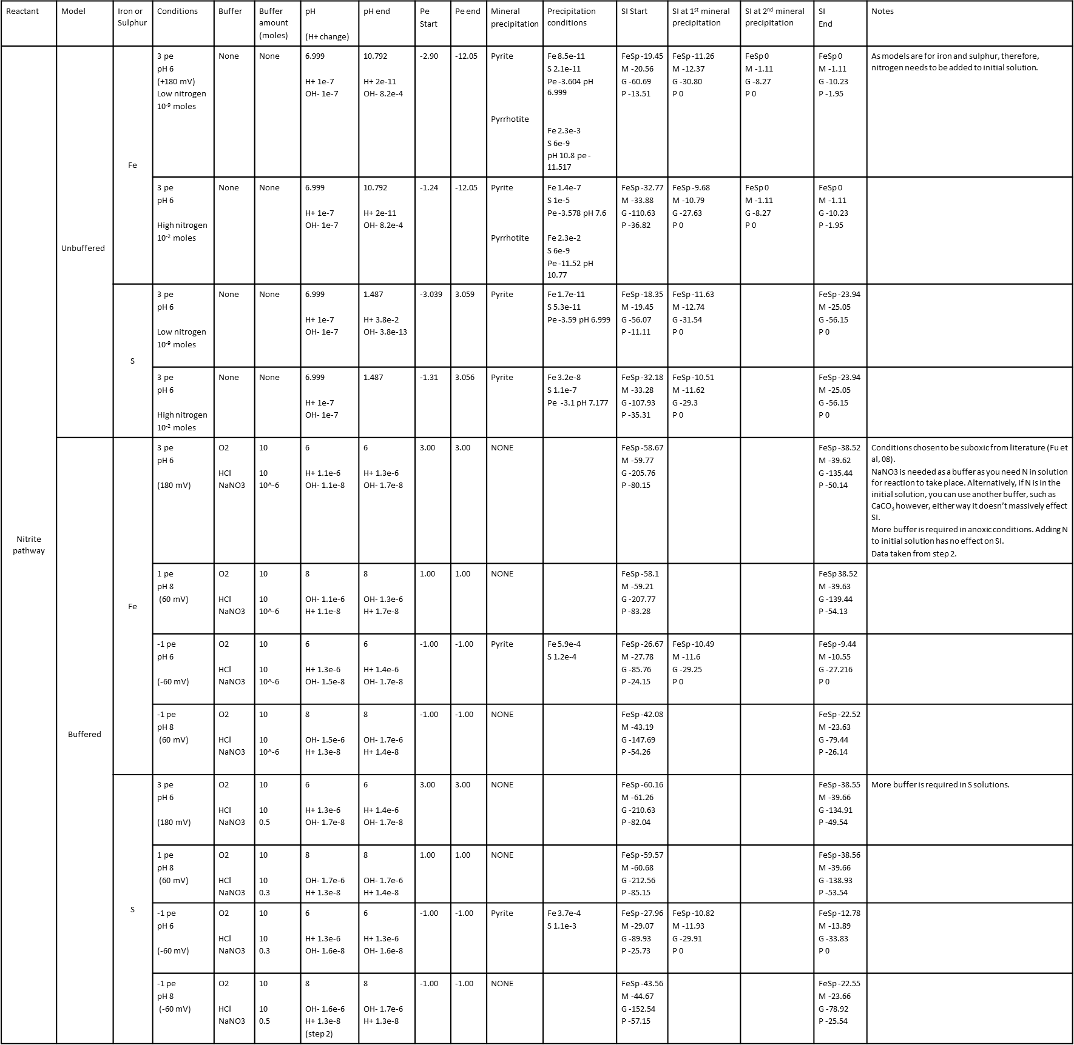

Table S7. Full experimental results for the nitrite pathway showing unbuffered and buffered solutions. Initial solutions have low (10-9 m) and high (10-2 m) nitrogen concentrations. Concentrations measured by molality (m).

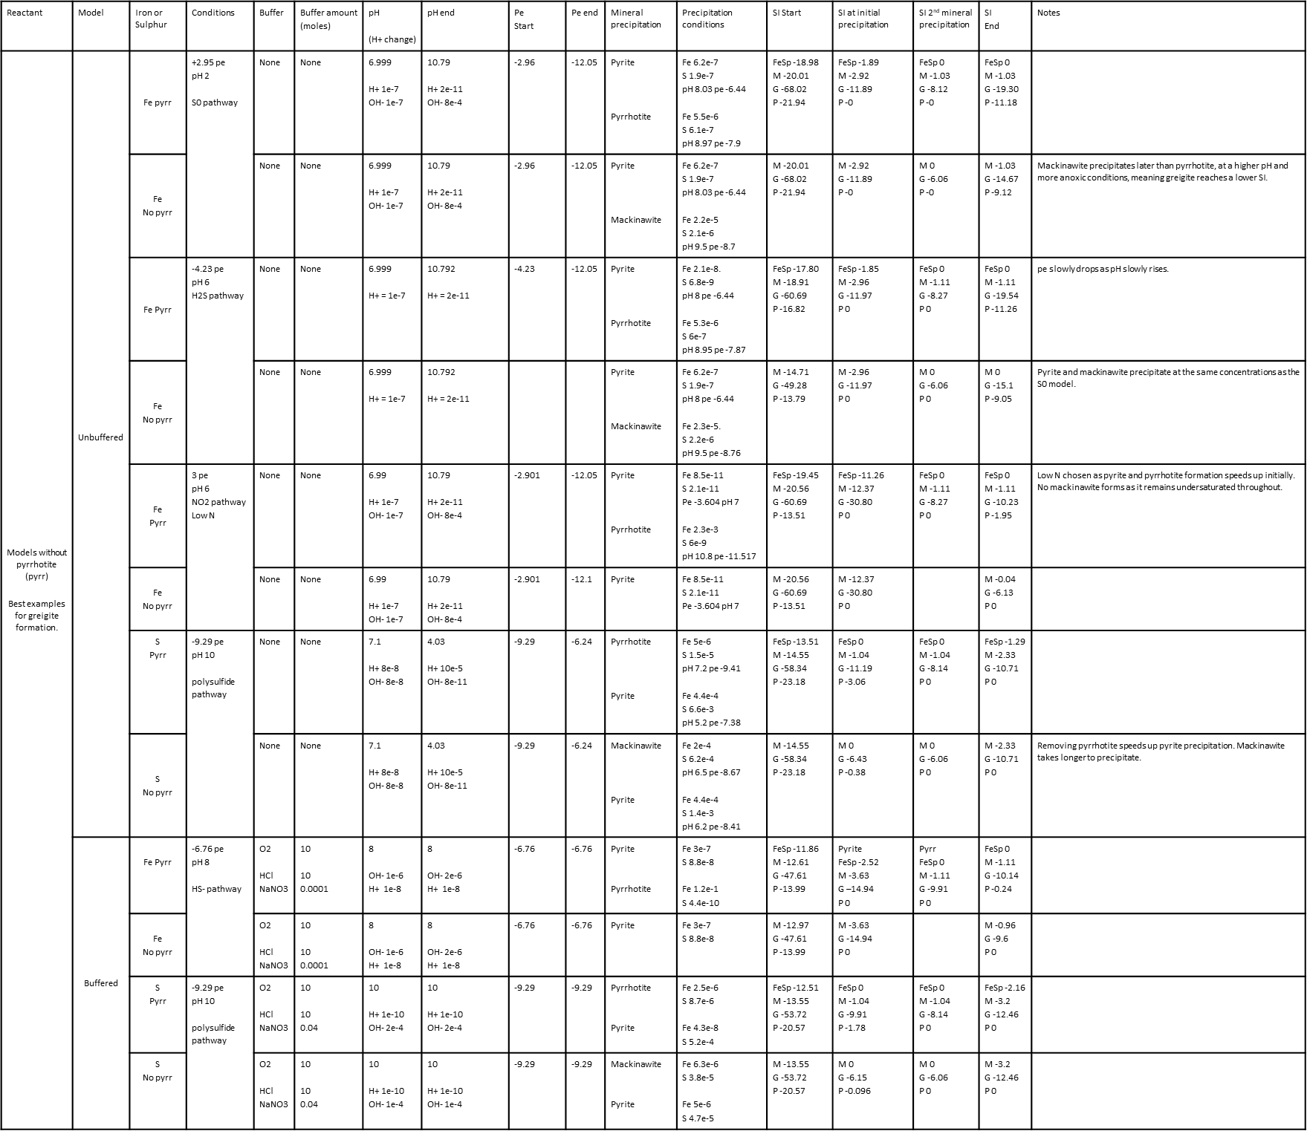

Table S8. Full experimental results showing comparisons between models with and without pyrrhotite. Models chosen produced greigite SIs that were closest to saturation with all minerals being at equilibrium. Concentrations measured by molality (m).

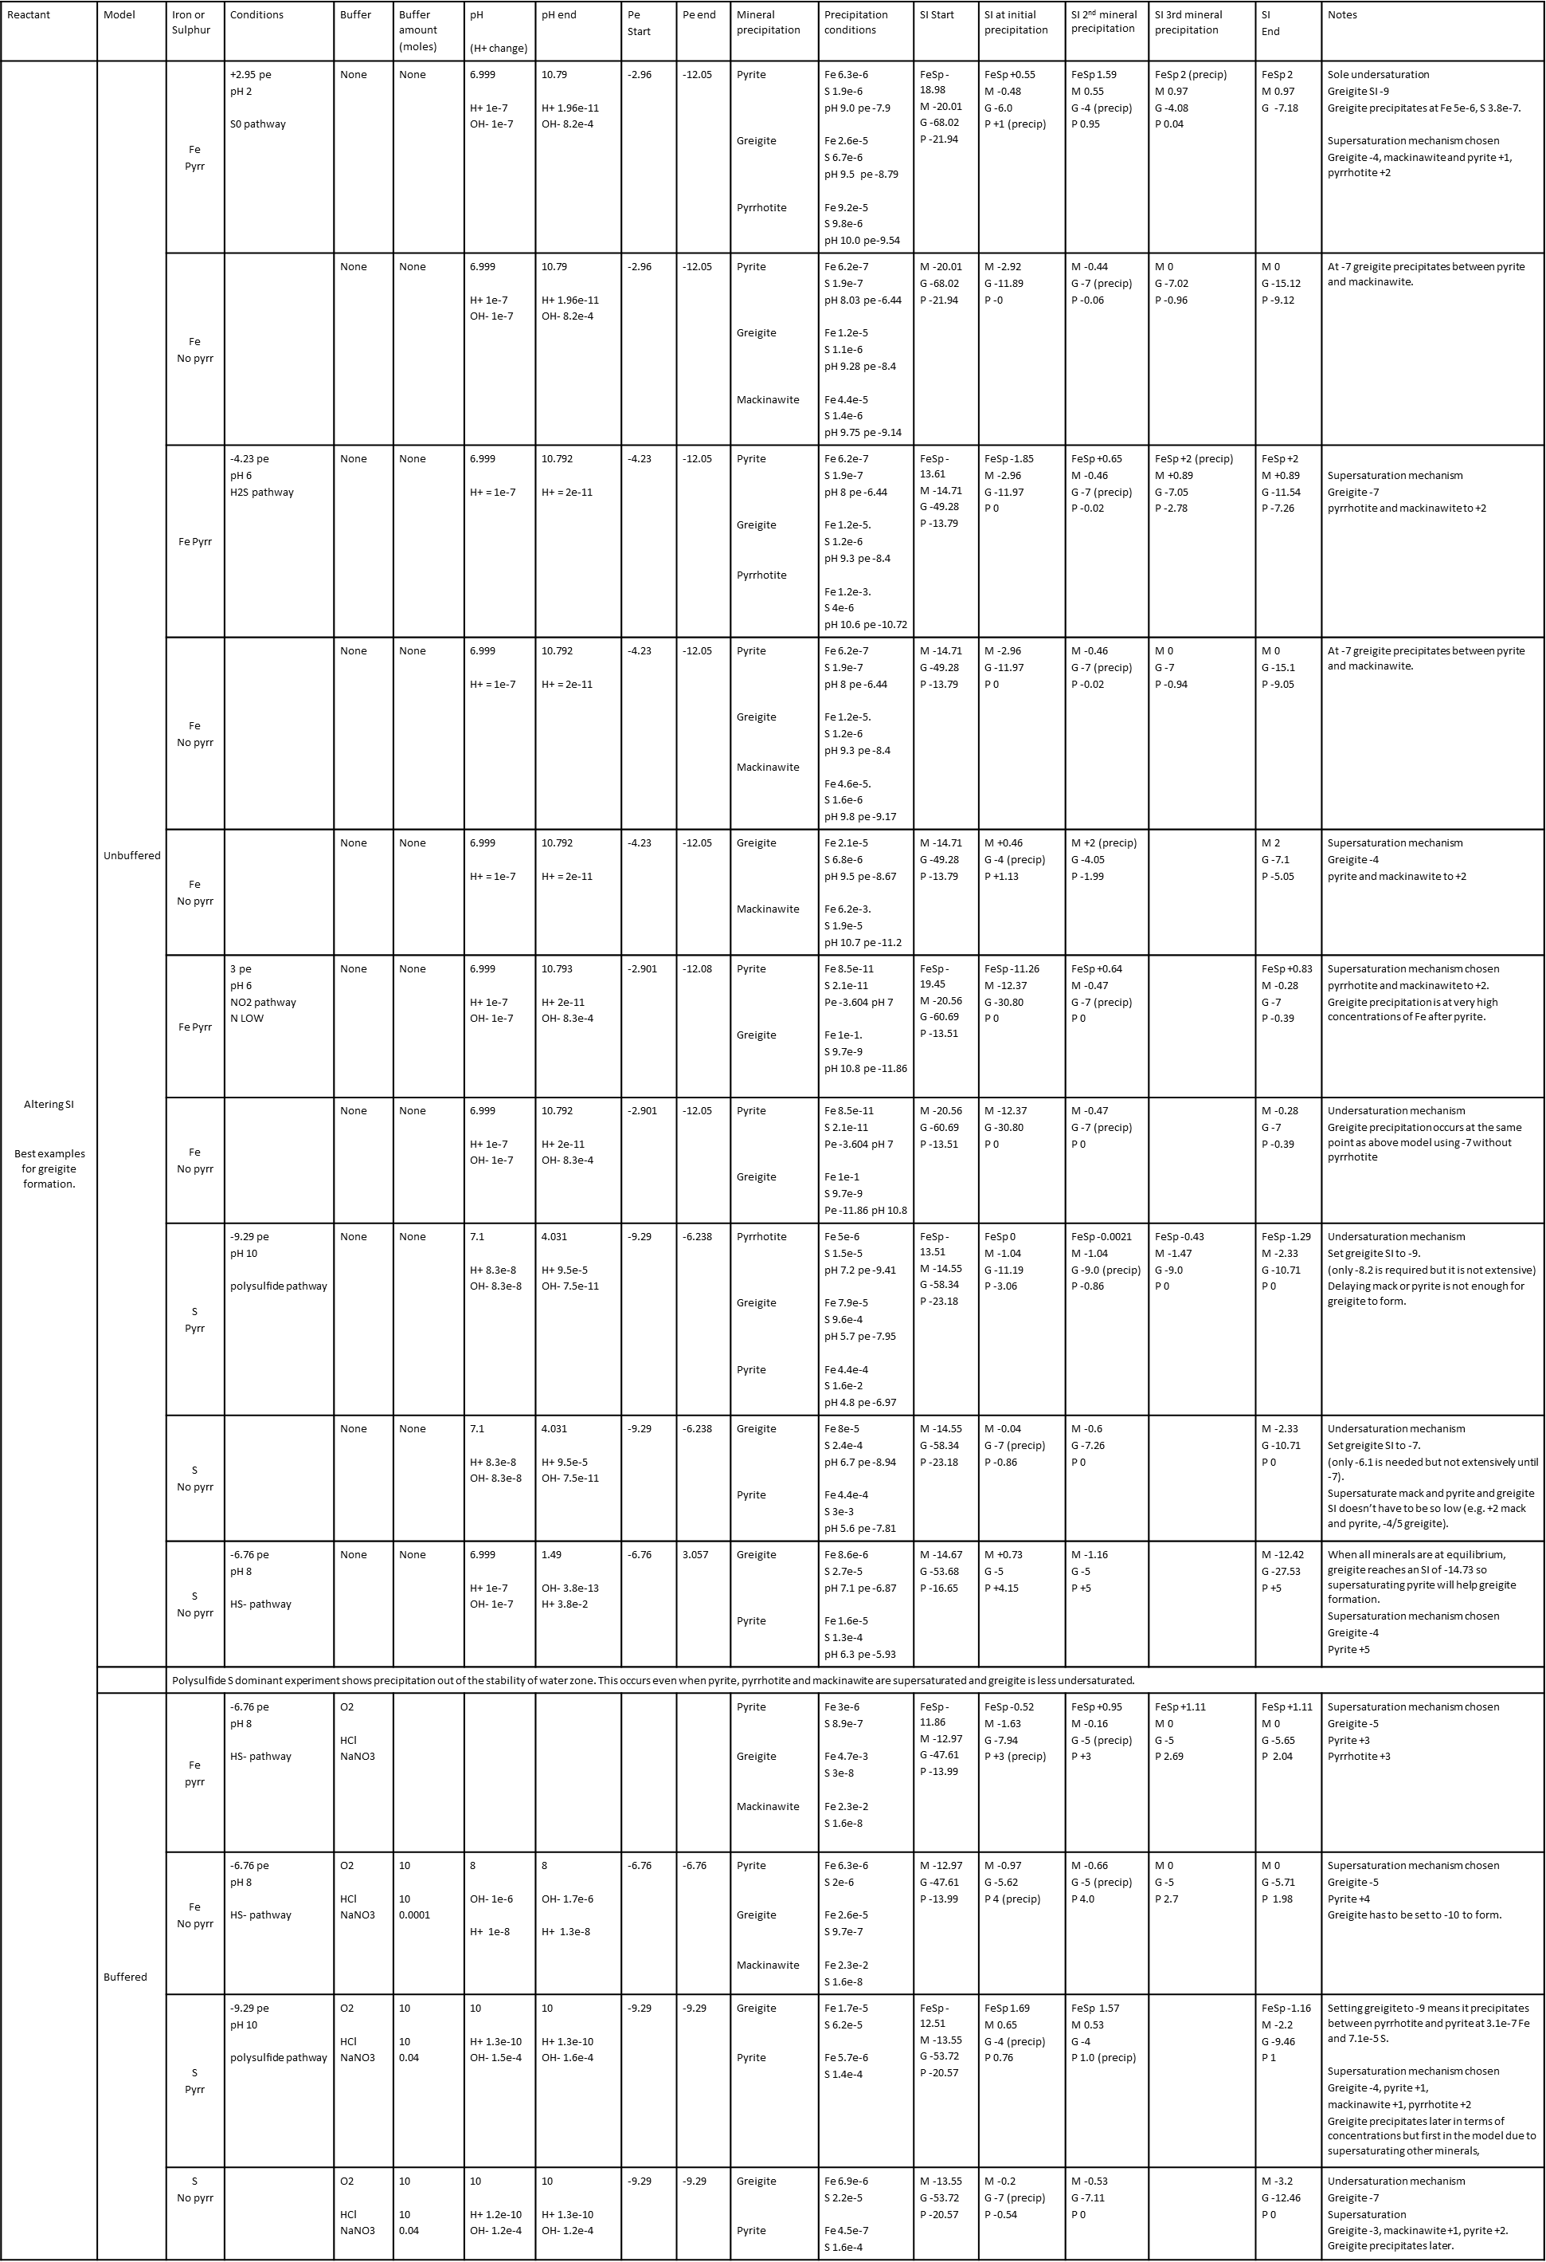

Table S9. Full experimental results for greigite forming models by the alteration of SIs. Models chosen produced greigite SIs that were closest to saturation with all minerals being at equilibrium. Concentrations measured by molality (m).

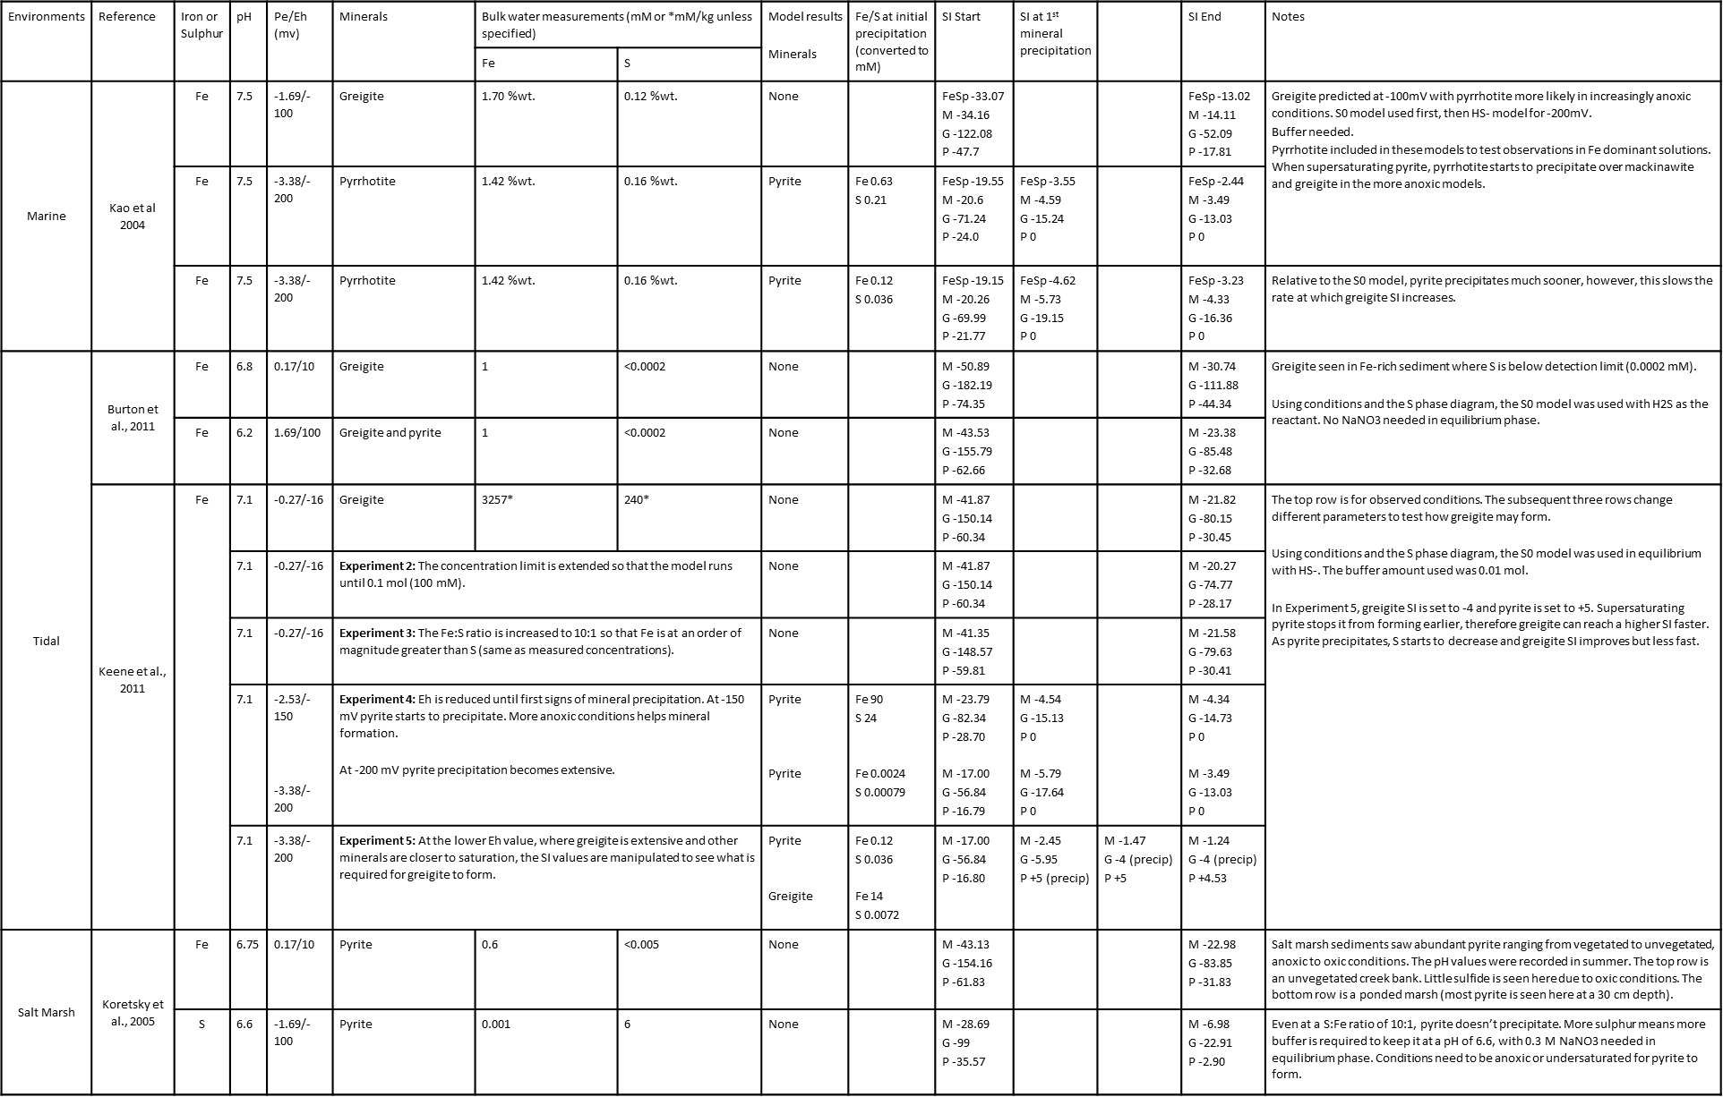

Table S10. Summary table of experiments when tested against literature observations. Using geochemical data from the literature, experiments were conducted then altered to promote the precipitation of iron sulphides. Concentrations measured by molality (m).

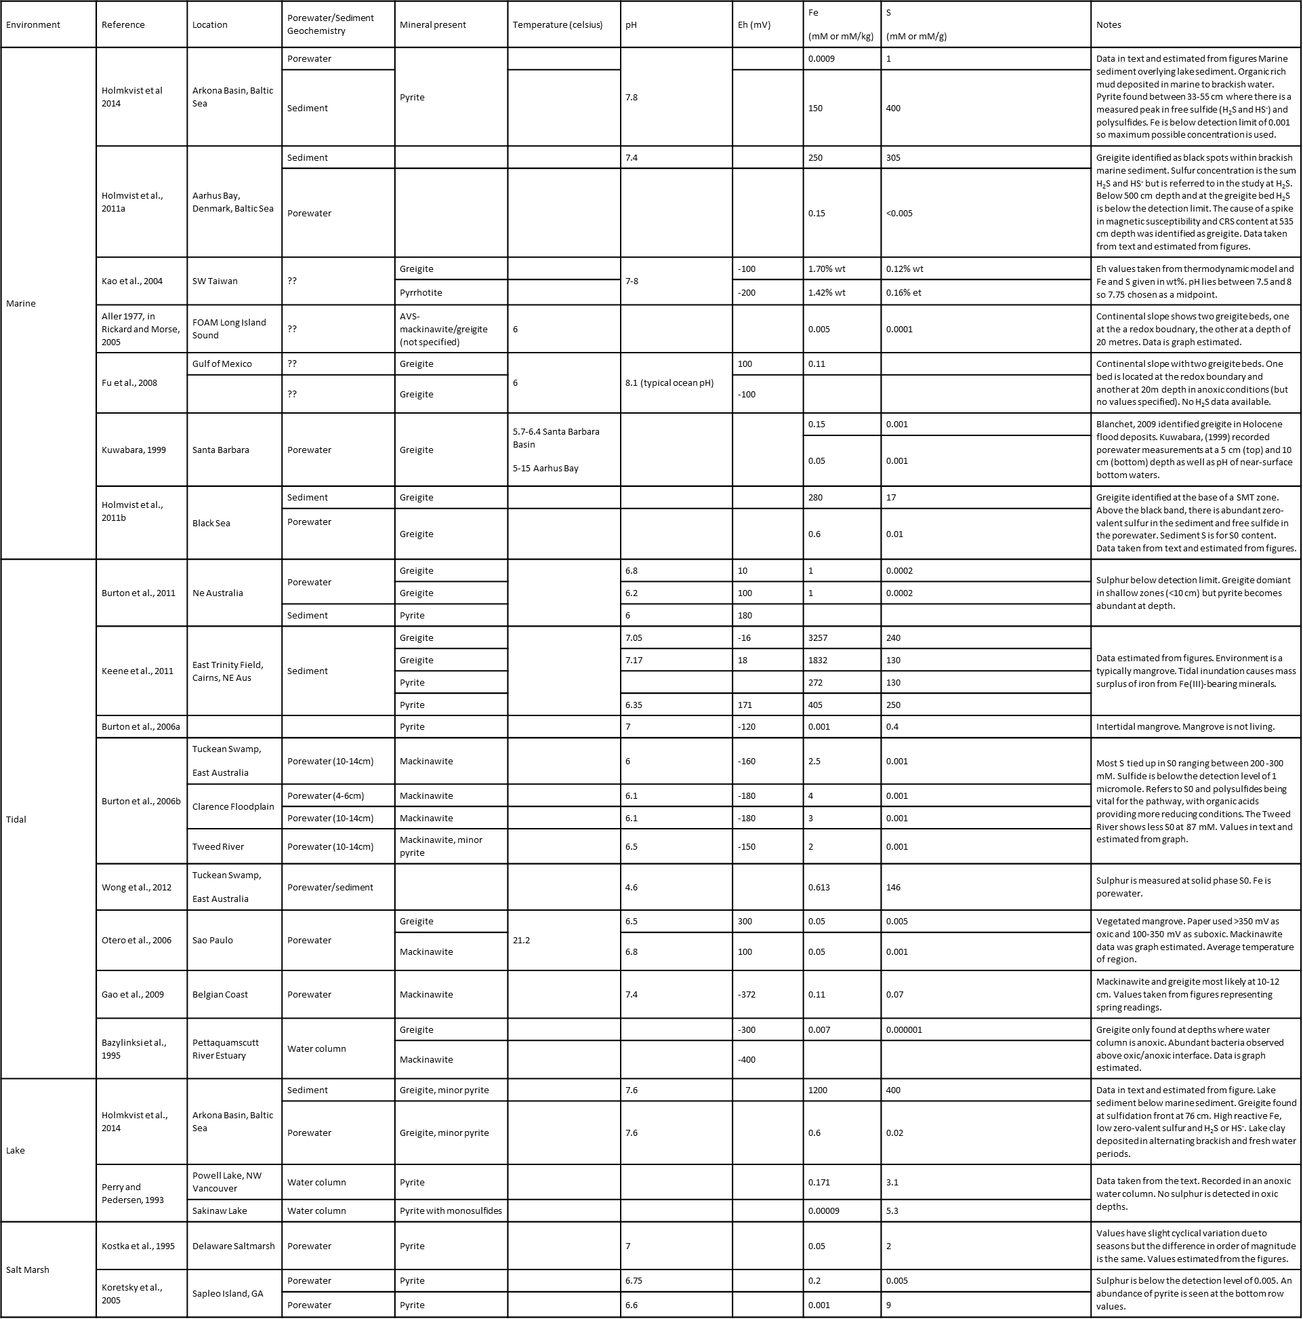

Table S11. Summary tables of geochemical data for iron sulphide-hosted natural sediments, taken from the literature. Values were estimated from the figures, taken from raw data or the text. Key observations have also been noted. Concentrations measured by molality (m).



Table S11 continued.

